Name ____________________________________________ TOTAL: /54

ARANMORE CATHOLIC COLLEGE


CHEMISTRY UNIT 1
2015
TEST FOUR: SOLUTIONS AND RATESOF REACTIONS

Part A: Multiple Choice (10 marks)

1. In which of the following solutions is the total concentration of ions [mol L⁻¹] the greatest?
a) 0.5 mol L⁻1 potassium chloride solution
b) 0.3 mol L⁻¹ calcium chloride solution
c) 0.2 mol L⁻¹ sodium sulfate solution.
d) 0.3 mol L⁻¹ aluminium chloride solution
e) 0.2 mol L⁻¹ aluminium carbonate solution.

2. Which one of the following would be an endothermic process?

- melting of ice
- combustion of petrol
- condensation of water vapour
- two hydrogen atoms forming a molecule

3. At room temperature, natural gas does not ignite spontaneously with oxygen gas from air because:

- the reaction is endothermic
- the activation energy is too small
- the collision energy is not usually large enough to overcome the bonding forces of the reactants
- the energy of the reactants is much greater than that of the products

- Rutile (TiO₂) reacts with chlorine and carbon at high temperature according to the
following equation:

TiO₂ _{(s)} + 2 Cl₂ _{(g)} + 2 C (graphite) → TiCl₄ _{(g)} + 2 CO_{(g)} ΔH = -77 kJ

Which of the following can increase the rate of the above reaction?
- Grinding the TiO₂ and C into smaller particles
- Increasing the temperature
- Increasing the pressure

- i only
- i and ii only
- i and iii only
- ii and iii only
- i, ii and iii

- A rise in temperature of gaseous reactants results in an increase in the rate of the reaction. This is mainly due to an increase in the:

- activation energy of the reaction
- proportion of molecules with energies greater than the activation energy
- proportion of molecules which dissociate into their constituent particles
- frequency of collisions between reactant molecules
- pressure inside the reaction vessel

- The following statements refer to the chemical reaction between CaCO₃ _{(s)} and dilute hydrochloric acid (HCl) solution producing a solution of CaCl₂ and CO₂ gas. Which one of the following statements is FALSE?

- the rate of the reaction decreases with increasing time
- the initial rate of reaction increases with increasing initial temperature
- the initial rate of reaction increases with decreasing amounts of CaCO_{3(s)}
- the initial rate of reaction decreases with decreasing initial concentration of H⁺ ions
- the initial rate of reaction increases with increasing subdivision of CaCO_{3(s)}

- Which of the following reactions are likely to be rapid at room temperature?

i. Ca²⁺_{(aq)} + CO₃²⁻_{(aq)} → CaCO_{3(s)}
ii. C₂H_{6(g)} + Cl_{2(g)} → C₂H₅Cl_{(l)} + HCl_{(g)}
iii. Sn²⁺_{(aq)} + 2Cu⁺_{(aq)} → Sn⁴⁺_{(aq)} + 2Cu²⁺_{(aq)}
iv. CH_{4(g)} + 2O_{2(g)} → CO_{2(g)} + 2H₂O_{(g)}

- i only
- i and ii only
- i and iii only
- ii and iv only
- iii and iv only

- A catalyst increases the rate of a reaction by:

  - increasing the energy of the reactants
  - lowering the energy of the products
  - lowering the activation energy
  - transferring the energy to the activated complex
  - energizing both products and reactants to some extent

Questions 9 and 10 are based on the following graphical representation of the reaction:

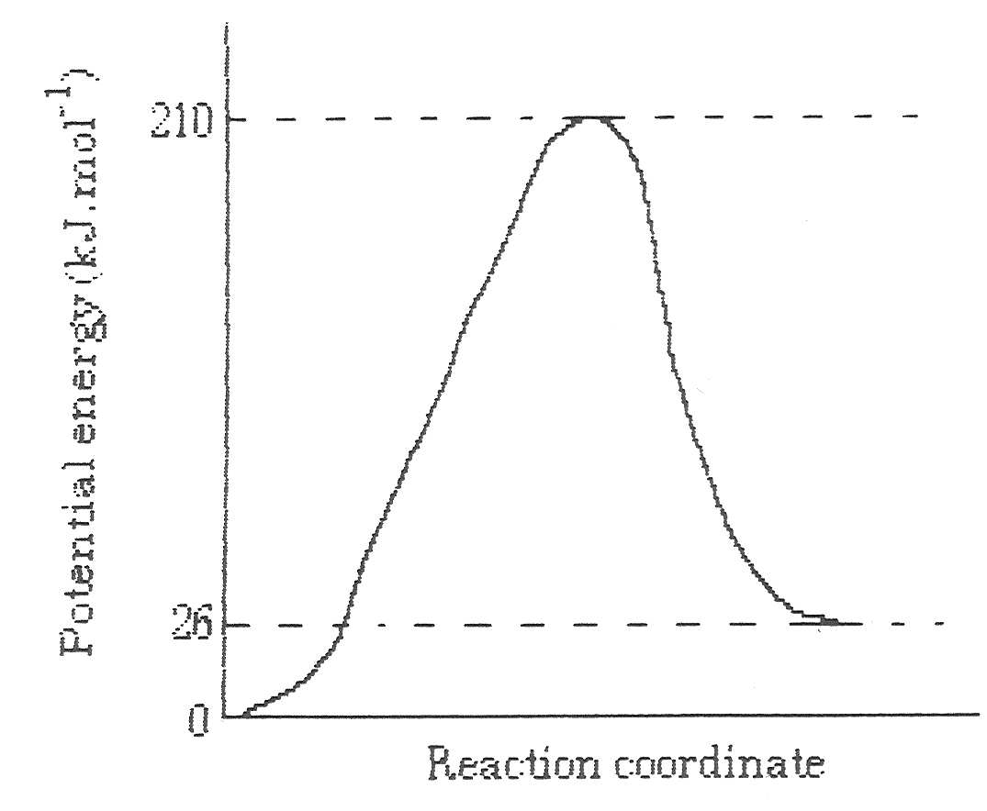
H_{2 (g)} + I_{2 (g)} → 2 HI_{(g)}

- For the reaction above, which of the following is TRUE?

  - it is an endothermic reaction with heat of reaction, ΔH = 26 kJ mol⁻¹
  - it is an exothermic reaction with heat of reaction, ΔH = 26 kJ mol⁻¹
  - it is an exothermic reaction with heat of reaction, ΔH = -26 kJ mol⁻¹
  - it is an endothermic reaction with heat of reaction, ΔH = 184 kJ mol⁻¹
  - it is an exothermic reaction with heat of reaction, ΔH = -184 kJ mol⁻¹

- The activation energy for the reverse reaction would be:

  - 26 kJ mol⁻¹
  - 92 kJ mol⁻¹
  - 184 kJ mol⁻¹
  - 210 kJ mol⁻¹
  - 236 kJ mol⁻¹

PART B SHORT ANSWER 44 MARKS

11. Match each of the terms in column A with its definition in column B: (3 marks)

Column A | Column B
- saturated solution  - unsaturated solution  - concentrated solution  - molarity  - dilute solution  - supersaturated solution | ____ the maximum amount of solute is dissolved at a given temperature.  ____ contains only a small amount of solute  ____ a crystal added to an aqueous solution will dissolve  ____ contains more solute than it can theoretically hold at a given temperature  ____ a solution with a large amount of solute  ____ the number of moles of solute dissolved in 1L of solution

12. Calculate the concentration in mol L⁻¹ of sodium ions present in a solution formed by mixing 200mL of 2.0 mol L⁻¹ sodium hydroxide with 320mL of 4.0 mol L⁻¹ sodium nitrate. (3 marks)

13. A 750mL bottle of household bleach contains 9g L⁻¹ of sodium hydroxide. Calculate the mass of sodium hydroxide in the bottle (show your working): (2 marks)

14. What is the percentage composition by mass of a potassium nitrate solution that has been prepared by dissolving 13g of potassium nitrate in 650g of water? (2 marks)

15.. What volume of 6.0 mol L⁻¹ NaOH is required to prepare 1.2L of a 2.50 mol L⁻¹ solution?
(2 marks)

16. A solution of sodium carbonate was prepared by dissolving 0.4637 g of anhydrous Na₂CO₃ solid in a small amount of water then making the solution up to a volume of 250.0 mL. The final mass of the solution is 250.6 g. Determine the concentration of the solution in each of the following units:

a) moles per litre (mol L⁻¹) b) grams per litre (g L⁻¹)
c) percentage by mass (% by mass)
(6 marks)

17. Write BALANCED IONIC equations for any reactions that occur in the following procedures. If no reaction occurs write ‘no reaction’ (if a reaction occurs but the change is not visible, you should also state this). In each case describe in full what you would observe including any:
• Colours • Odours • Precipitates (give the colour)
• Gases evolved (give the colour or describe as colourless)
(9 marks)
a) Iron (III) chloride solution is added to a solution of sodium carbonate.

Equation:

Observations:

b) Potassium nitrate solution is added to a solution of sodium iodide.

Equation:

Observations:

c) Copper (II) nitrate solution is added to a sodium hydroxide solution.

Equation:

Observations:

18. For each of the following reactions, what property would you measure to indicate the rate of the reaction?
[3 marks]
a) Fe_{(s)} + 2H⁺_{(aq)} → Fe²⁺_{(aq)} + H_{2(g)}

b) 2I⁻_{(aq)} + H₂O_{2(aq)} + 2H⁺_{(aq)} → 2H₂O_{(l)} + I_{2(s)}

c) CaCO_{3(s)} → CaO_{(s)} + CO_{2(g)}

19. Ethene can be produced by heating ethane in the presence of a catalyst. The equation can be represented as follows:

C₂H_{6(g)} → C₂H_{4(g)} + H_{2(g)} ΔH = + 120kJ

Sketch an energy profile diagram (Potential Energy / Progress of Reaction) for this reaction. The energy of activation is decreased from 180 kJ mol⁻¹ to 140 kJ mol⁻¹ with the addition of the catalyst. Show each of the following on your graph:
(6 Marks)

a) The energy of the products

b) The energy of the reactants

c) The reaction pathway if the reaction is carried out without a catalyst

d) The reaction pathway if the reaction is carried out with the catalyst.

20. Sketch the enthalpy versus reaction progress diagrams for the following reactions:
(4 Marks)
a) potassium metal reacts violently when added to water producing potassium hydroxide solution and hydrogen gas, which spontaneously ignites.

b) 2H₂O_{(l)} + O_{2(g)} → 2H₂O_{2(aq)} ΔH = 98 kJ

21. A sample of rock salt is mainly composed of sodium chloride. Calculate the percentage purity of this rock salt if 50.7 mL of 0.180 mol L⁻¹ silver nitrate was required to precipitate all the chloride ions contained in 0.556 g of the sample (of rock salt), according to the following equation.
(4marks)
AgNO₃ + NaCl → AgCl + NaNO₃

